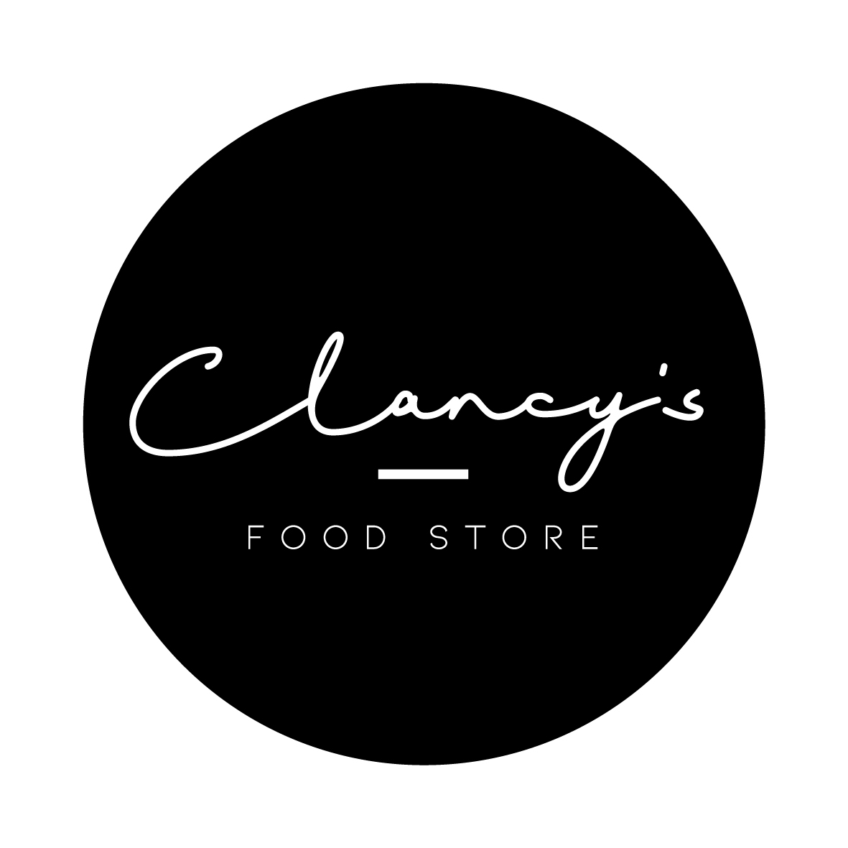
CATERING MENU
591 Smollett St, Albury p: 02 6021 0580
e: clancysfoodstorealbury@gmail.com

SAVOURIES

MINI SAVOURIES - (minimum order of doz)
Classic Sausage Rolls (18 pk) $22.90
Pumpkin & Ricotta rolls (18pk) $23.90
Party Pies (Doz) $20.00
Savoury Tartlets (Doz) $20.00
BAGUETTES (cut & boxed into 3 or 6) $ 11.40
Poached chicken, avo, sundried tom
Poached chicken and salad
Poached chicken, celery, spring onion
Smoked Ham and salad
Smoked ham, pickle, cheese
Smoked salmon and capers
Smoked salmon, capers, avo, cucumber
Roasted vegetable

RICE PAPER ROLLS (gf) $ 5.45
Sweet chilli chicken
Poached chicken and avo
Vegetarian
Smoked salmon
Seasonal

ENTERTAINER SAVOURY TARTS* $29.90
Pumpkin, Spinach & Feta
Bacon, Basil oil & Cherry Tomato
Roasted Vegetable Frittata (gf)
* Cuts into 20 bite-size pieces

SEASONAL FRUIT PLATTERS serves 6-12 $49.00

SWEET TREATS PLATTERS serves 6-12 $75.00

CATERING MENU
591 Smollett St, Albury p: 02 6021 0580
e: clancysfoodstorealbury@gmail.com

FROM THE FREEZER

CURRIES Approx 500g or 1kg serves
Butter Chicken
Green Chicken Curry
Beef Massaman
Vegetable Bean Curry
Spaghetti Bolognaise Sauce
BEEF LASAGNE Small 1-2 Large 8-10
$17.00 $50.00

PIES 2 pack 4 pack
Classic Beef $13 $23
Gourmet Flavoured $14 $26

SEASONAL SALADS Small 1-2 Catering 8-12
Pesto Pasta $13.90 $50.00
Roast Pumpkin & Quinoa
Potato
Asian Slaw
Seasonal Garden

FROM THE PANTRY

A wide selection of food using quality suppliers with a focus on local products.

Please allow 24 hours notice for all catering. We will do our best to cater for your dietary needs.

